Report of the renovation work at Warewa Primary Health Center (PHC)

Introduction

This report provides an overview of the renovation undertaken at Warewa Primary Health Center (PHC) in Ifo LGA in Ogun State. The renovation resulted from a needs assessment conducted by ACIOE in collaboration with the National Primary Health Care Development Agency (NPHCDA) in eight selected facilities within two LGAs— Ifo and Obafemi Owode—from March 28 to March 30, 2023.
ACIOE engaged with the National Primary Health Care Development Agency and obtained primary health care facility checklists, including the Integrated Supportive Supervision Checklist, the medical equipment checklist, and the Drugs and Consumables Checklist. These tools were adapted to develop the assessment checklist utilized for the PHC assessment in Ogun State. NPHCDA also provided a comprehensive structural plan for a model Primary Health Center.
The decision to select Warewa PHC for renovation was based on several critical factors identified during the assessment process, such as RMNCH and immunization services, 24-hour services, its strategic location, and the model PHC structure of the facility. The purpose of the renovation was to enhance the facility's capacity to deliver quality healthcare services and standard healthcare delivery, thereby increasing the facility's utilization and improving health outcomes.
Before initiating the renovation process, ACIOE obtained formal approval from the Ogun State Ministry of Health and the Ogun State Primary Healthcare Agency. This was followed by coordination with the Health Secretary of Ifo Local Government to ensure local alignment and support for the project.

Community Engagement
The renovation began with a community entry meeting involving the engineer, local community members, a representative from the health secretary of the Ifo local government, and facility staff. The engagement was positive, fostering strong local support and enthusiasm for the planned upgrades and signaling a positive collaborative approach to enhancing community health.

Key Renovation Activities

Roofing Works:
The renovation started with the building's roofing. Upon removing the old roof, it was discovered that the wooden structures supporting it were extensively damaged and required total replacement. This necessary step was important to ensure the safety and durability of the new roof. Although this was not envisaged as part of the work, replacing the wooden structures was essential to uphold structural integrity and guarantee a long-lasting roof that could withstand environmental conditions and provide a safe environment for staff and patients.

Plumbing and scaffold installation:
The plumbing work required extensive repairs to damaged pipes throughout the facility and fabricating a tank stand for the water storage tank. Days before the renovation began, the pumping machine for the PHC's borehole was stolen. The pumping machine was replaced with a new pumping system to ease water access in the facility and improve the PHC's water supply to all the wards, consulting rooms, and the center's overall functionality.

Power Supply Reconnection:
The PHC has been without electricity for over a year due to a pending bill of ₦1.3 million, and medical healthcare was done in the facility without a power supply. ACIOE settled an outstanding N1,300,000 electricity bill and purchased a prepaid meter, allowing for more sustainable power management. This reconnection, rewiring, and new lighting installations ensure a consistent power supply for medical equipment and essential medical services.

Structural and Facility Upgrades:
To improve Warewa PHC's infrastructure and patient care environment the renovation covered other areas, which included;
- Replacement of the entire ceilings of the structure
- Replacement of all windows with modern sliding windows, doors with brand new doors and keys, and the installation of burglary-proof mosquito net on all windows.
- Replacement of 13 toilets and wash hand basins, including toilet seats, toilet doors, windows, and tiles.
- Replacement of the entire plumbing pipes of the facility
- Comprehensive rewiring, installation of new electrical sockets, and ceiling fans for adequate ventilation and lighting
- Landscaping of the premises to improve the aesthetics of the facility and driveway reconstruction to improve vehicle accessibility.
- Painting of the building's interior and exterior.
- Perimeter fencing adjustments for added security.
- New ceiling structure in the reception area and ceiling fan installation in the facility.
- Renovation of Security house
- Addition of an external handwashing station for improved hygiene access.

Medical Equipment and Supplies
To also improve the functionality of the primary health center (PHC) and healthcare delivery, ACIOE equipped Warewa PHC with state-of-the-art medical devices and basic supplies, which include:
- 1 Olympus Microscope for the laboratory
- 1 six-bucket Centrifuge for the laboratory
- Double door 461-liter Refrigerator
- 1 Autoclave pressure steam sterilizing unit
- 2 Stethoscope
- 2 tabletop BP machine
- 1 Digital BP Machine
- 2 Glucometer Machines
- 5 Boxes of Glucometer test stripes
- 7 boxes of Malaria test Kits
- 5 boxes of PT
- Carton of Cotton Wool
- Carton of Hand gloves
- ½ carton of facemask
- 3 Color-coded Pedal Bin
- 10 Autoclavable stainless bed pan
- 2 Drive Medical Blue streak lightweight Wheelchairs
- 200kg Digital height and weight scale for adults
- 2 Stainless steel double tier instrument trolley
- 1 digital weighing scale for babies
- 1 Oxygen set- cylinder and regulator/mask
- 15 Artery, dissecting and obstetrics forceps
- 4 sets of large, Medium and small Kidney dishes
- Two 7 feet black pharmacy shelves
- One first-aid box
- One family planning storage cabinet
- Three Stainless steel instrument tray
- 1 ½ cartons of 5 ml and 2ml injection
- 11 crank hospital beds
- 11 hospital Mattresses
- 11 Mackintosh hospital pillows
- 10 hospital bedside lockers
- Three 4-panel stainless ward screen
- 8 set of black colored 3-seater reception chairs
- Large-sized first aid box
- 2 pairs adjustable clutches
- 2 Packs of Underlay
- Clamp
- 5 black office tables
- 5 black office chairs
- Bedsheets and 22 pillowcases
- 10 ceiling fans
- 1 32" TV set
- 1 Go TV decoder

ACIOE's extensive renovation of Warewa PHC demonstrates a commitment to strengthening primary healthcare services in Nigeria. This fully refurbished facility, now equipped with advanced medical equipment and secure, hygienic infrastructure, will vastly improve healthcare quality and accessibility for Warewa residents. This milestone highlights the impact of targeted healthcare investment, addressing immediate healthcare needs while setting the foundation for long-term health improvements for the community.
ACIOE is committed to supporting primary healthcare delivery, promoting health equity, and fostering sustainable health outcomes within underserved communities.

Before Renovation

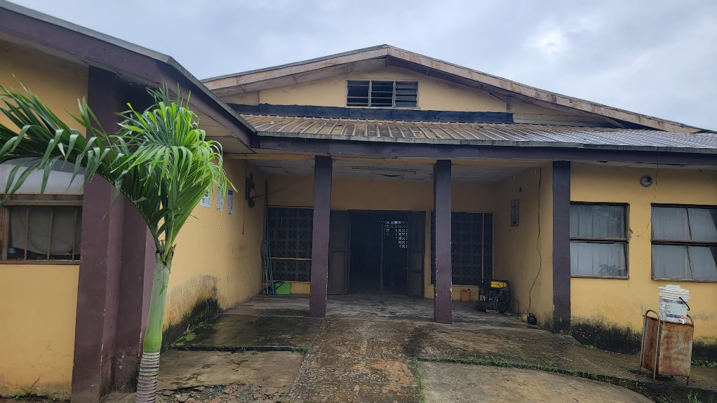

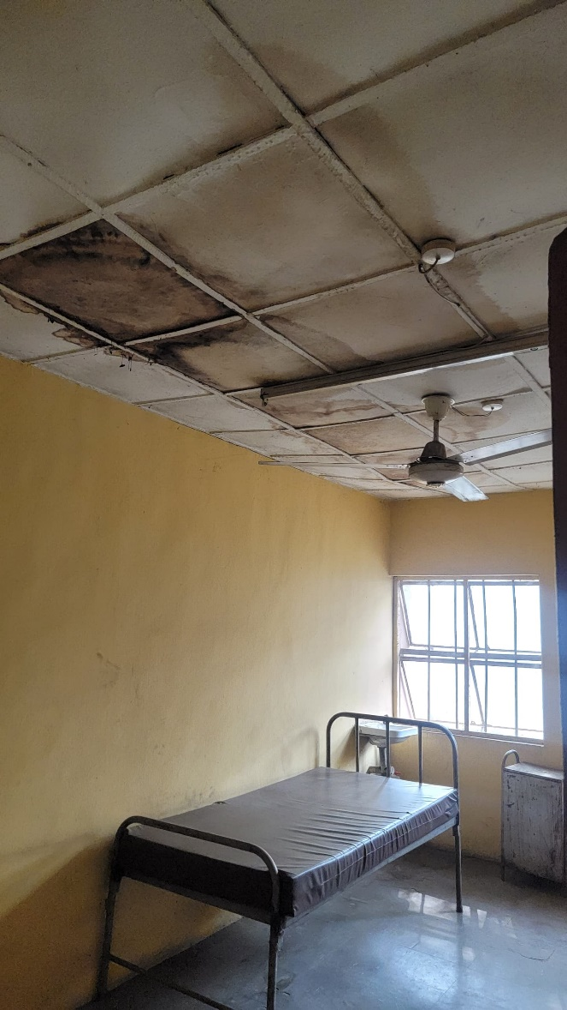
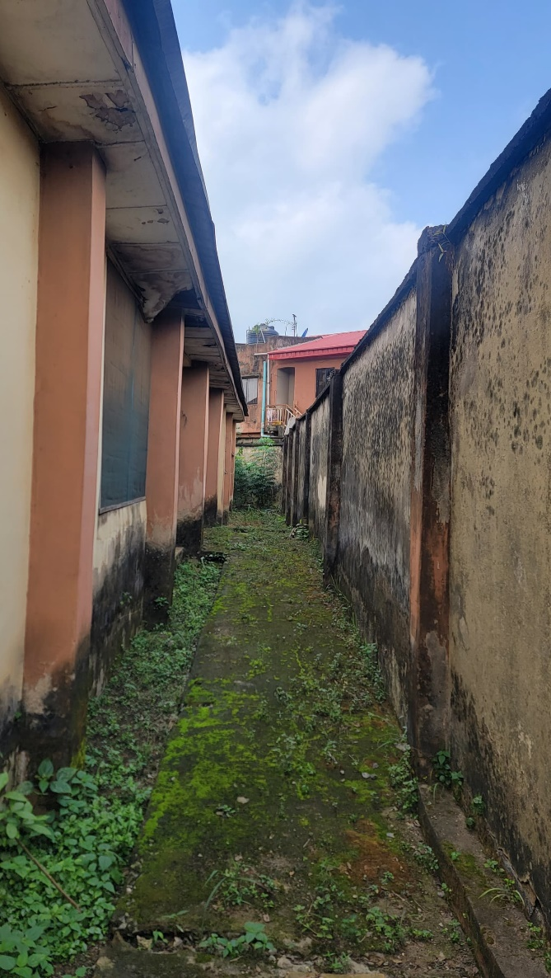

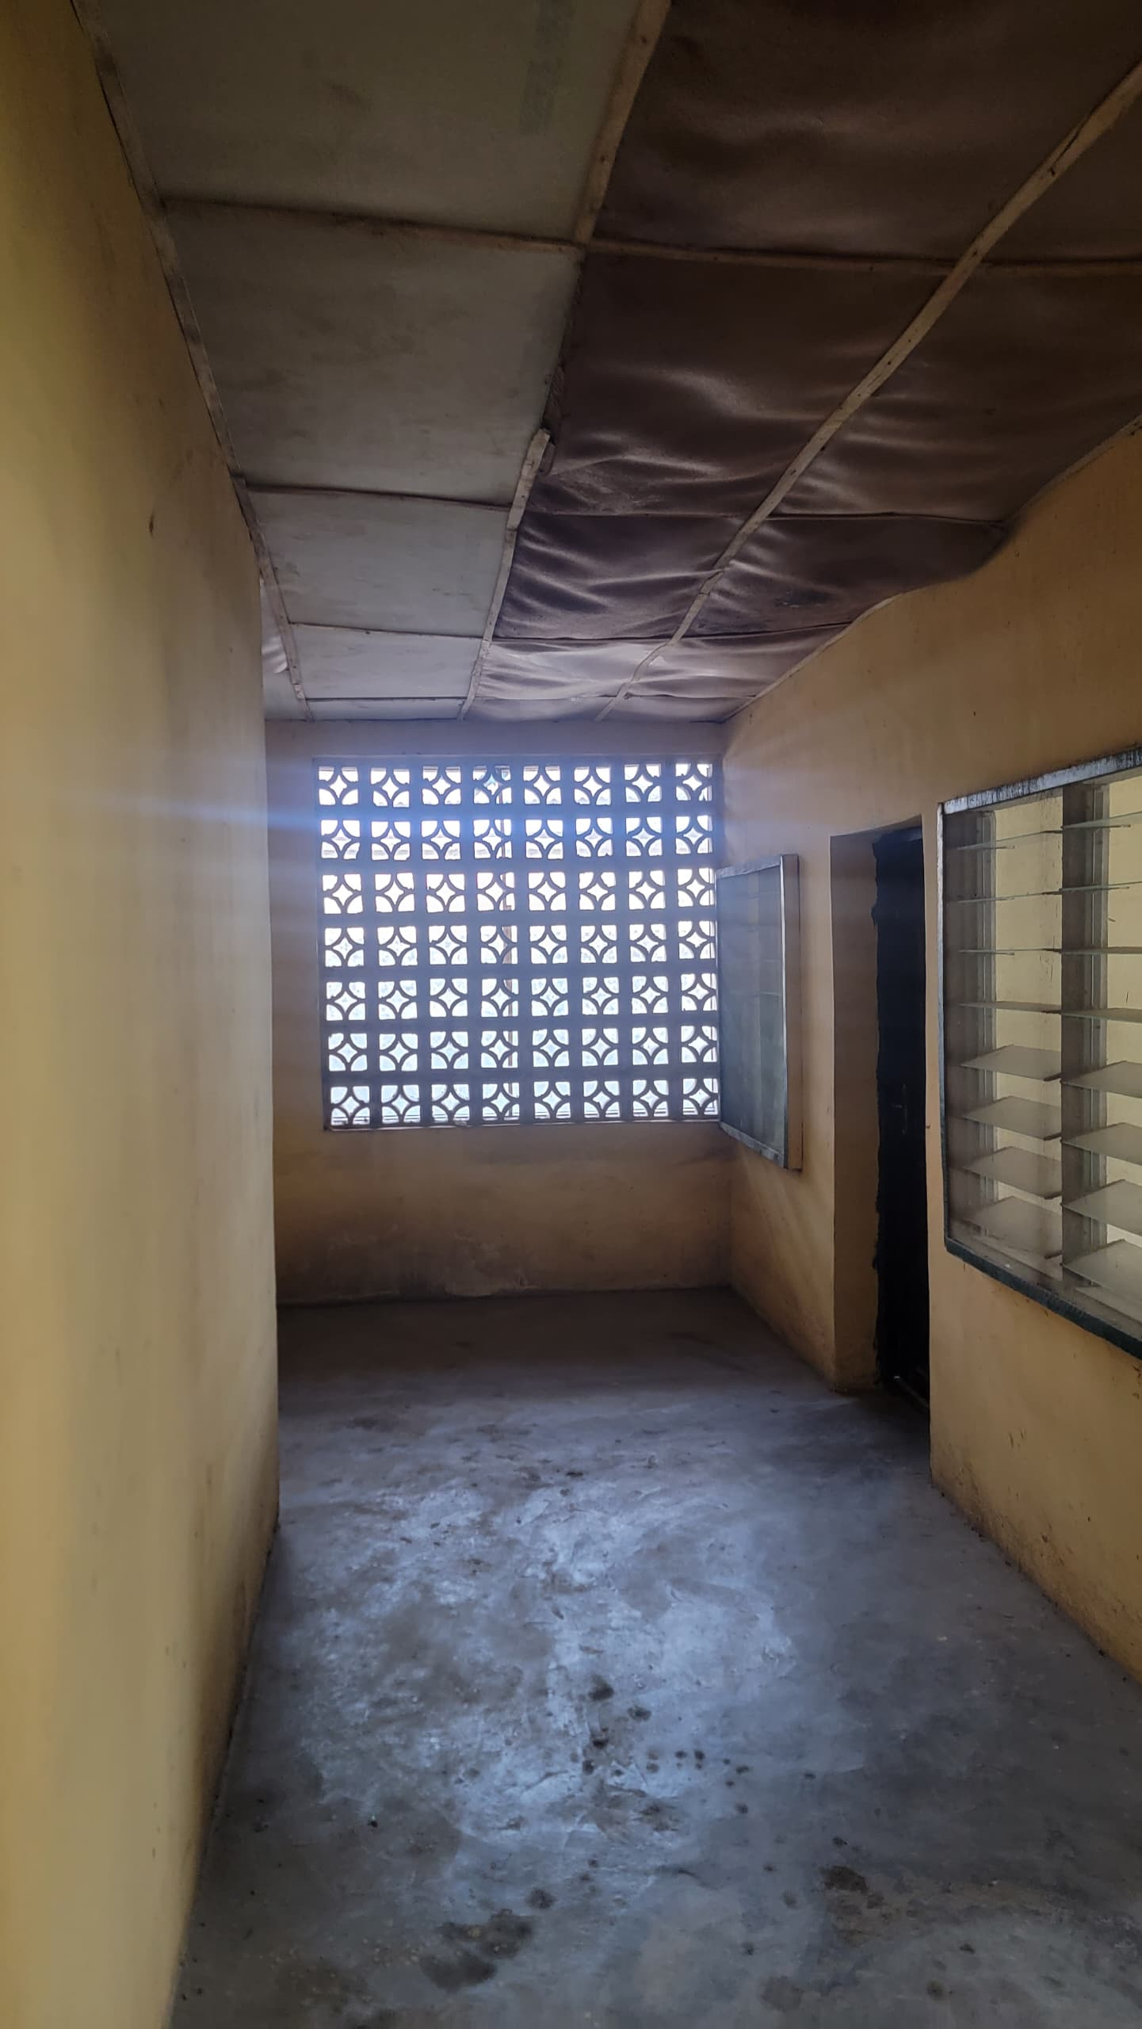
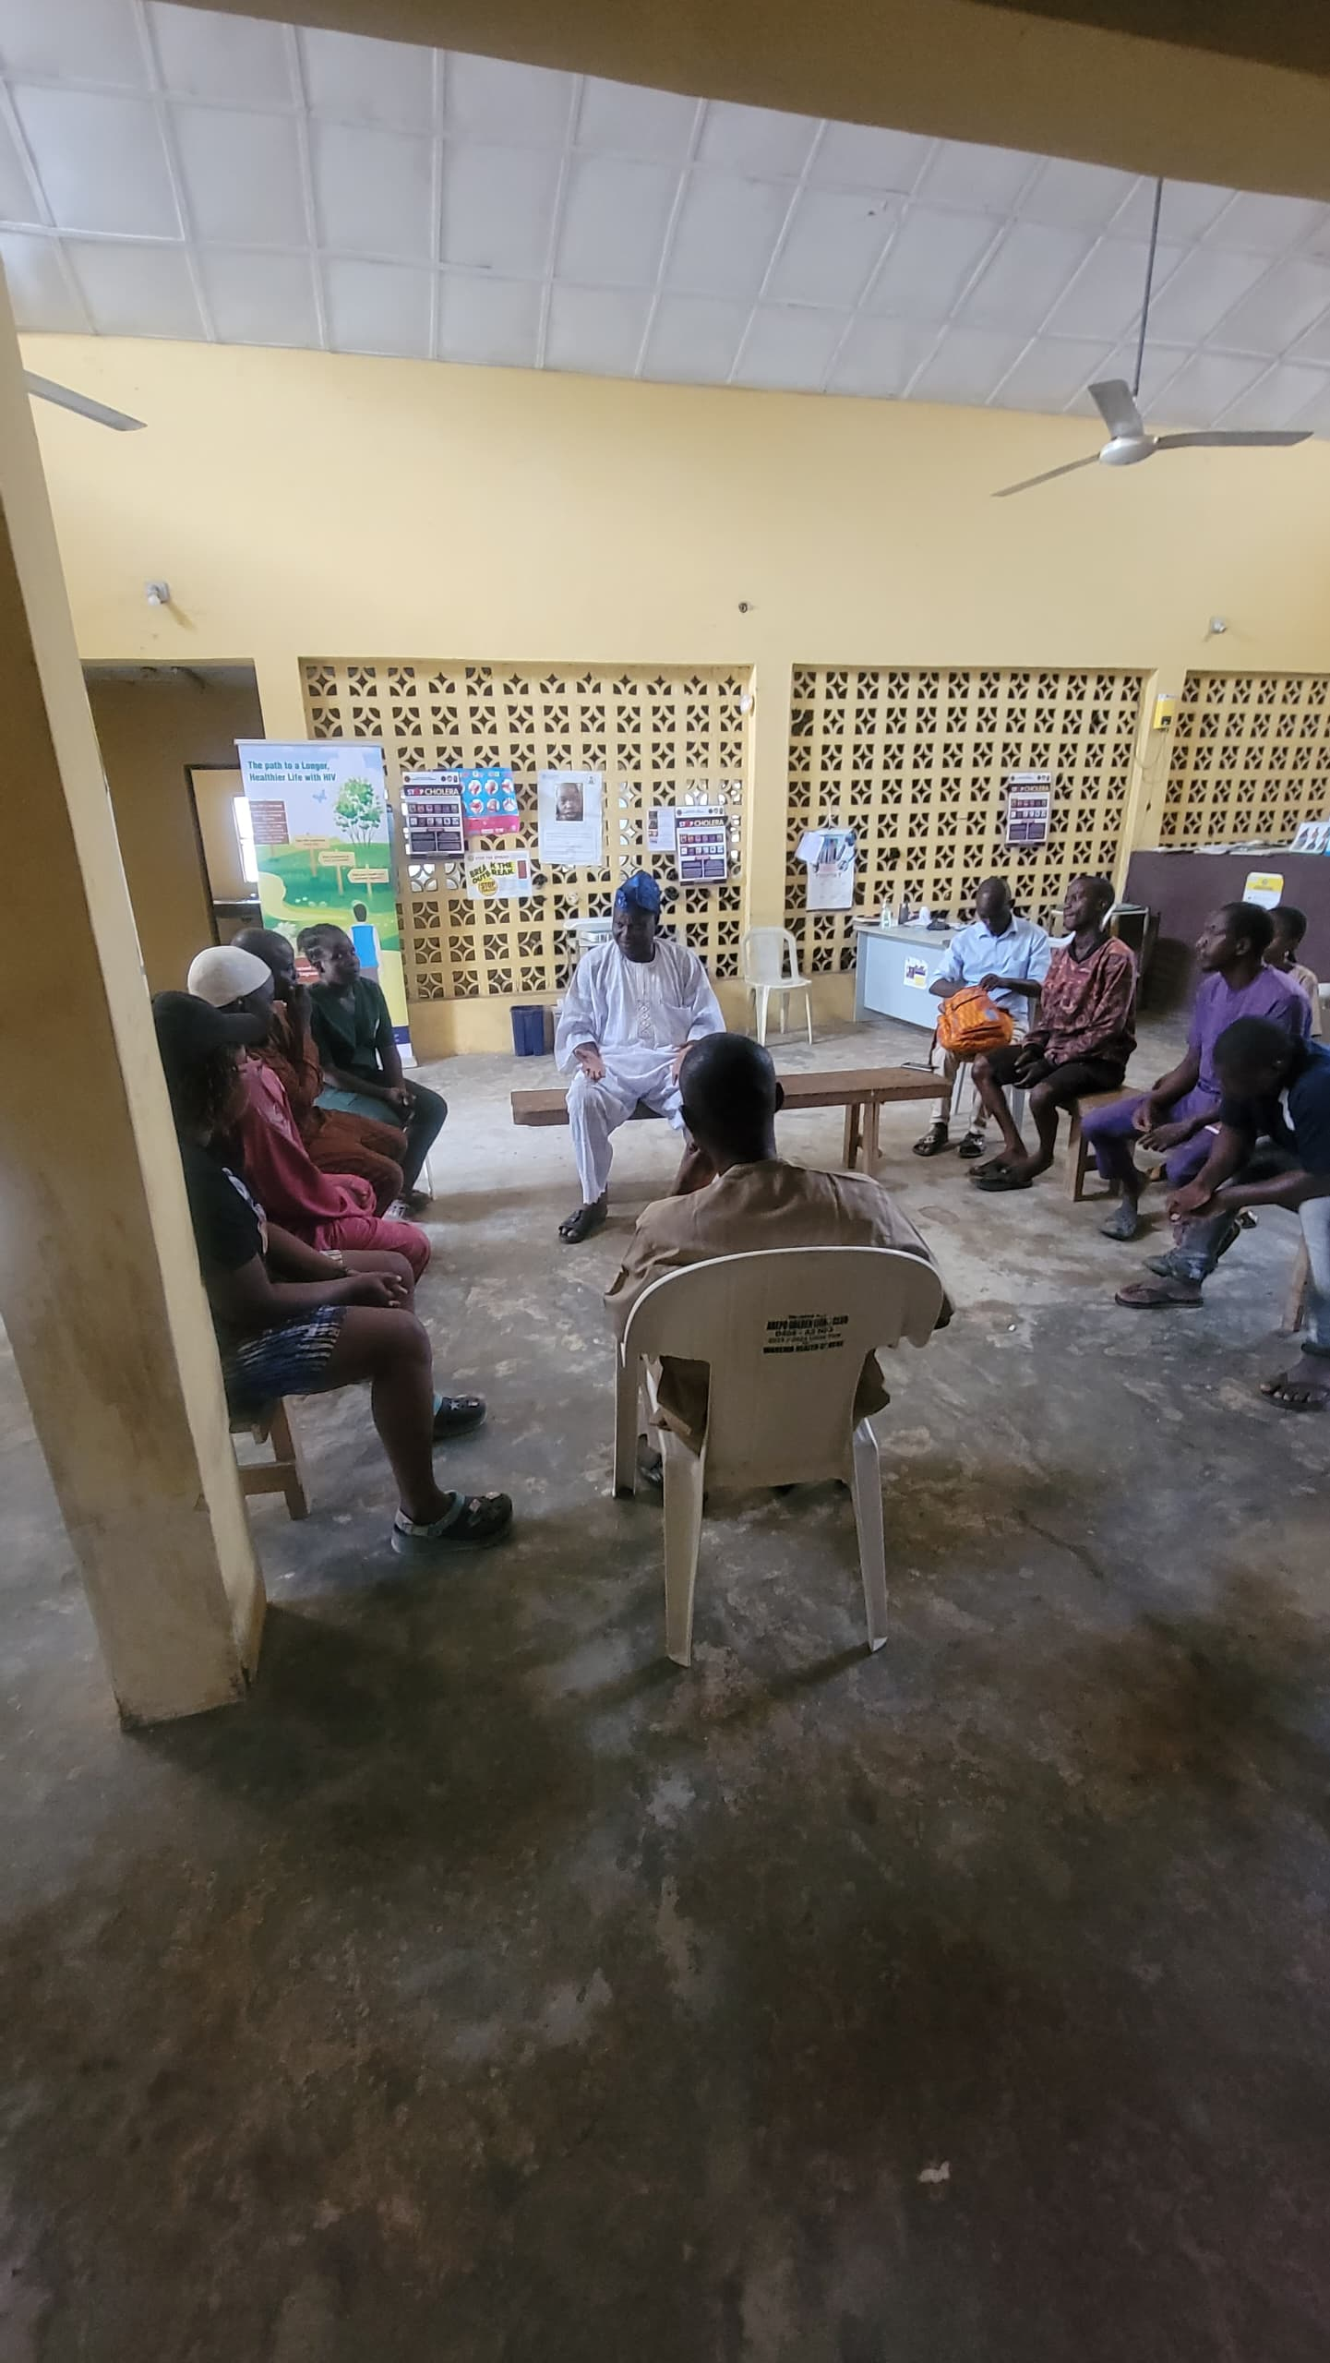

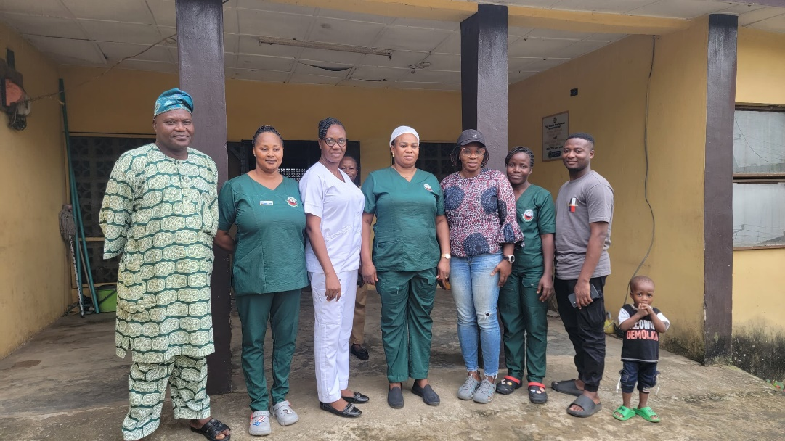

Community entry meeting in Warewa PHC
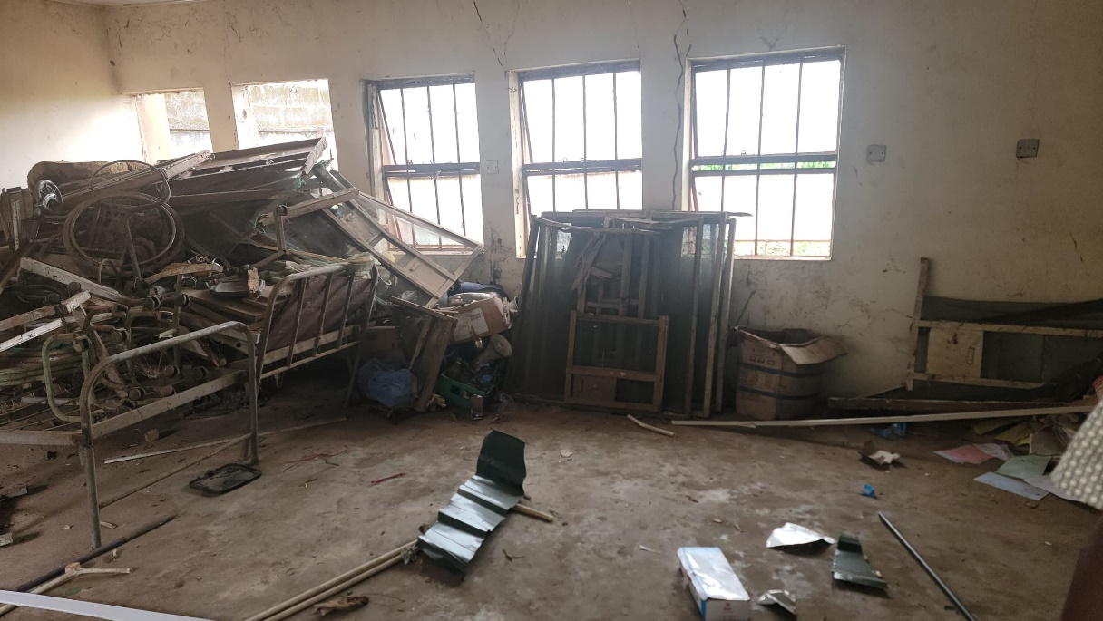

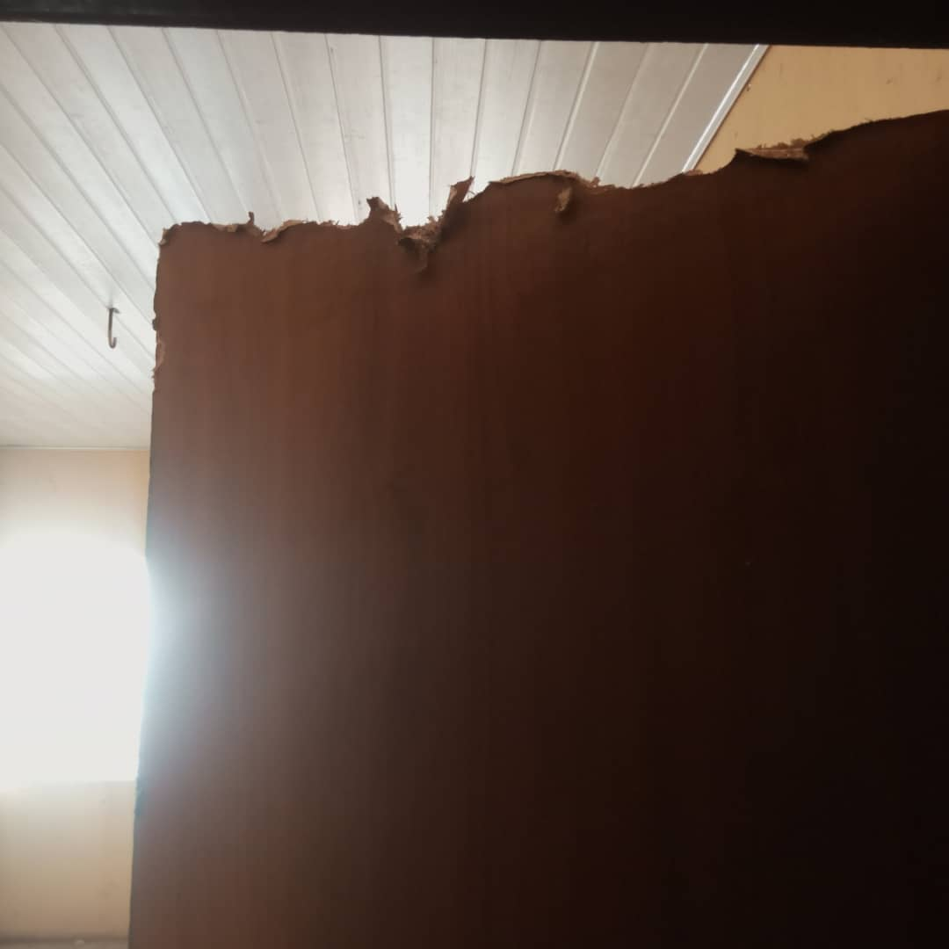
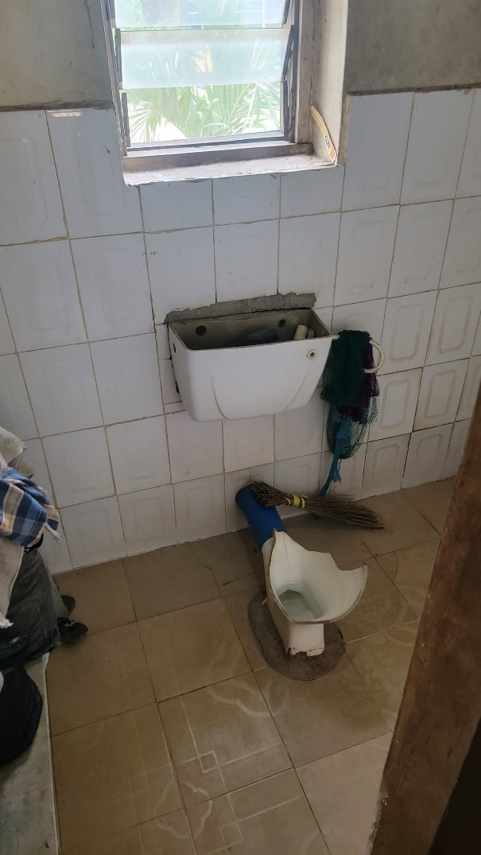

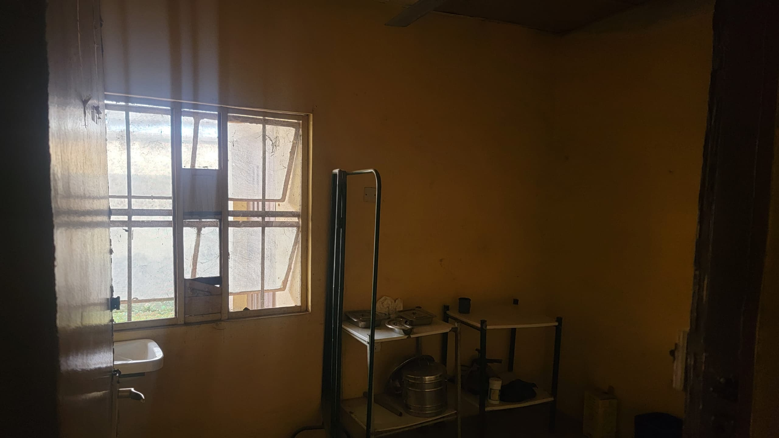

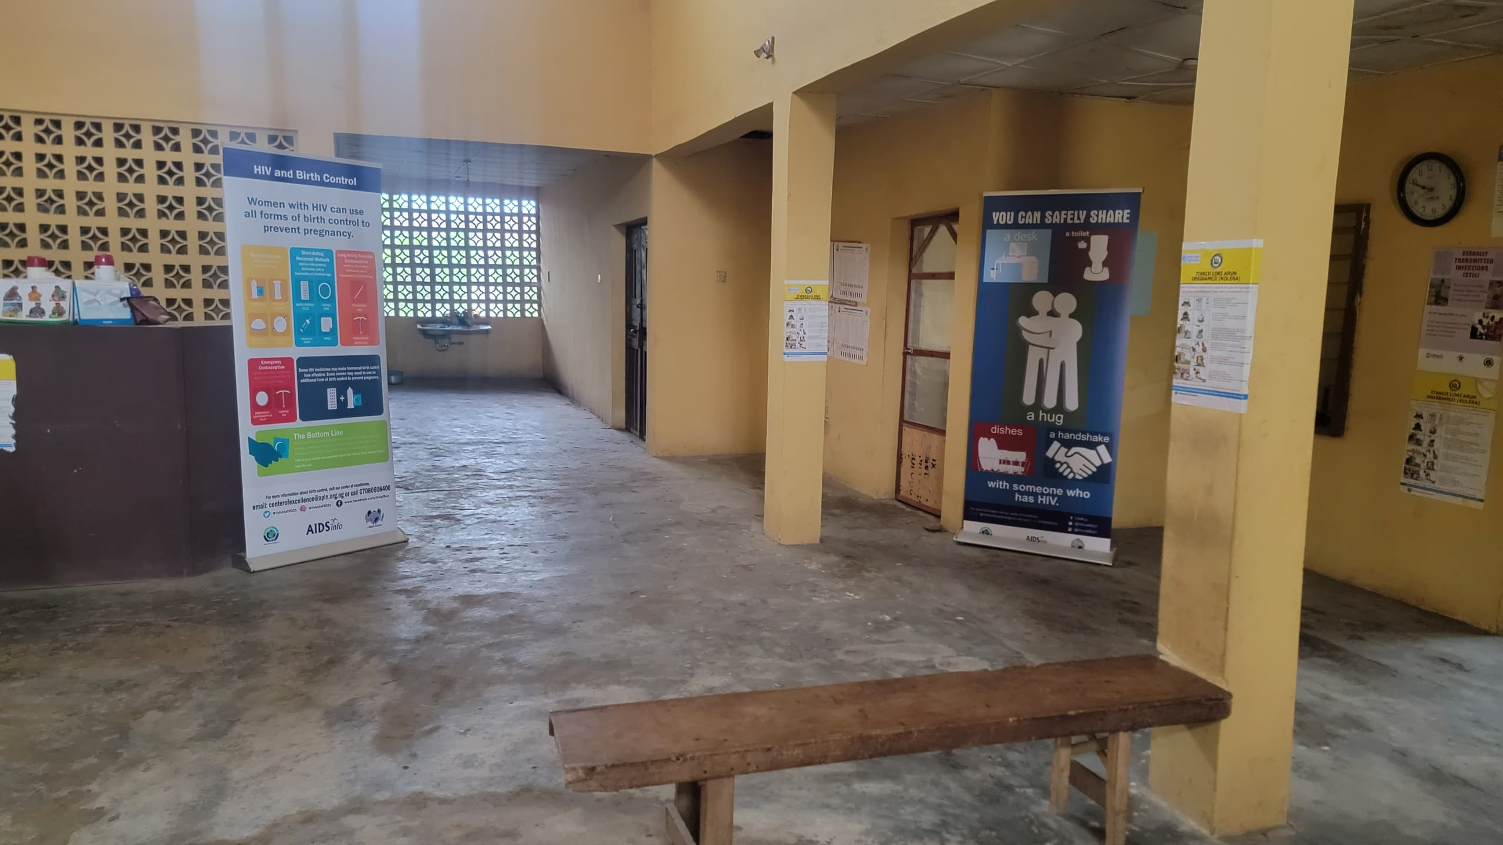

During Renovation

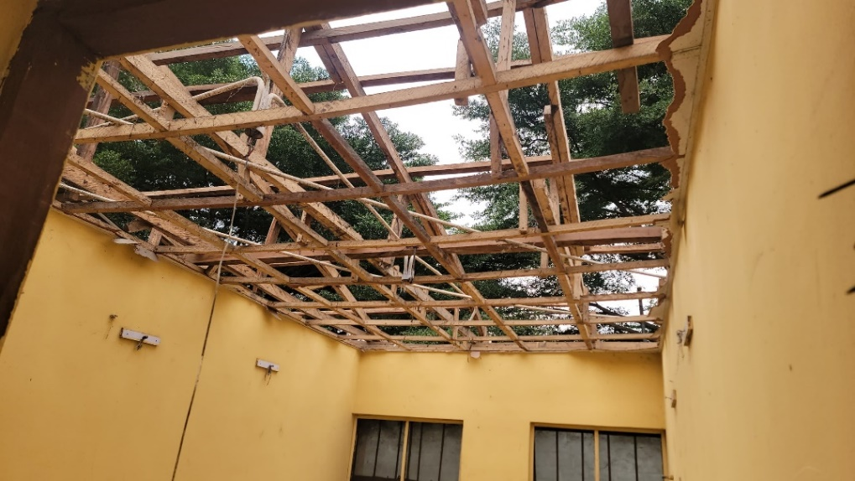

Removal of roofing sheet

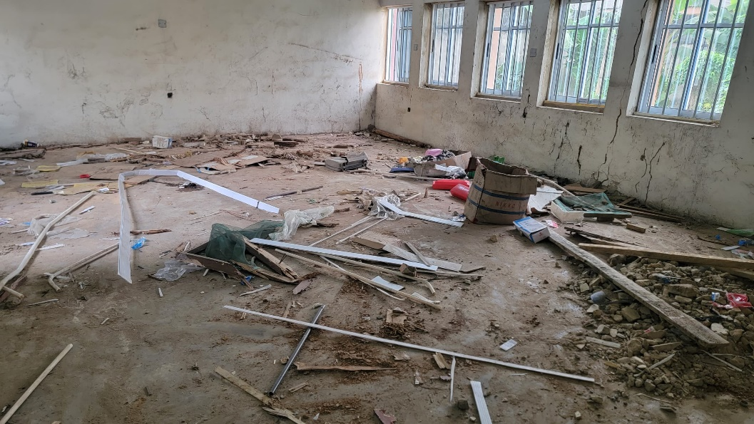

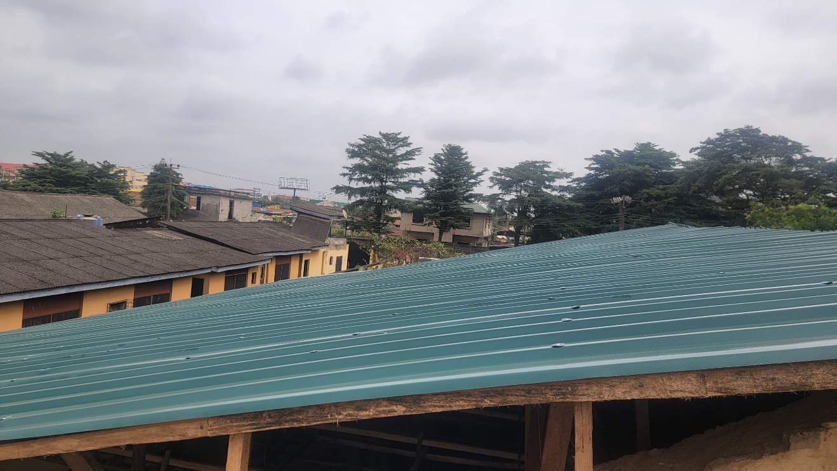
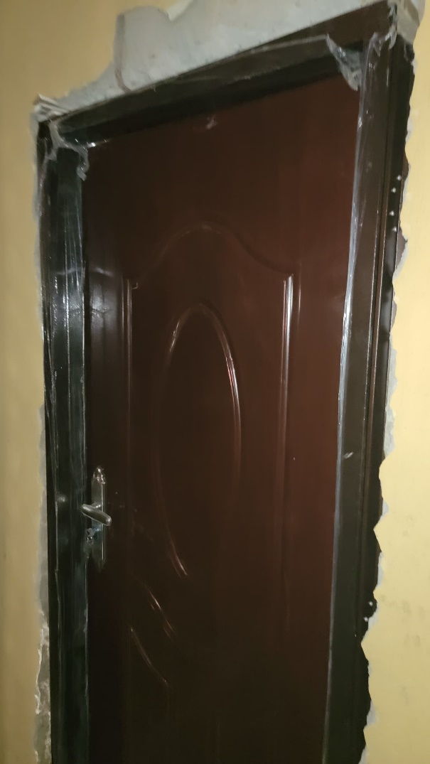
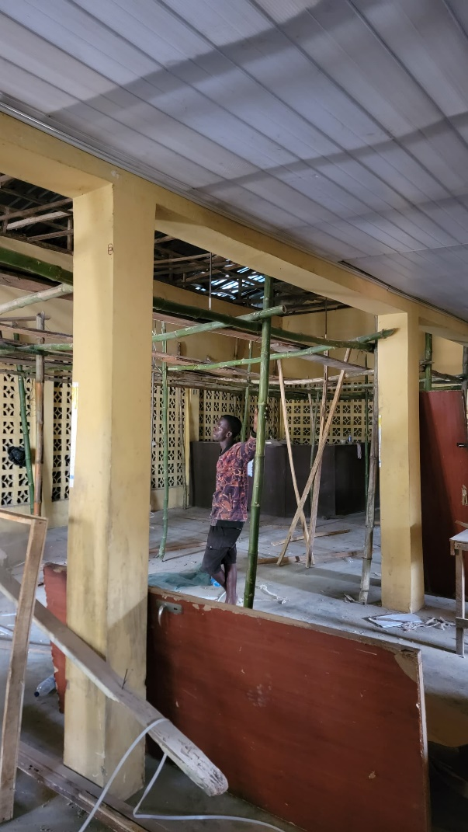
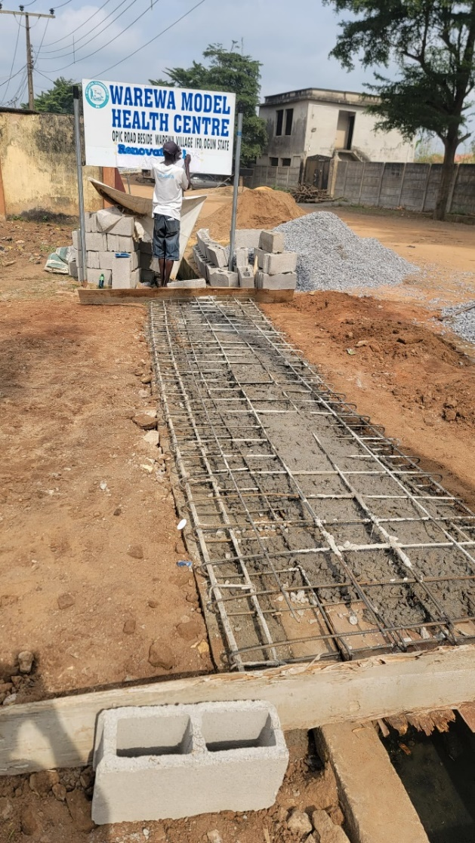
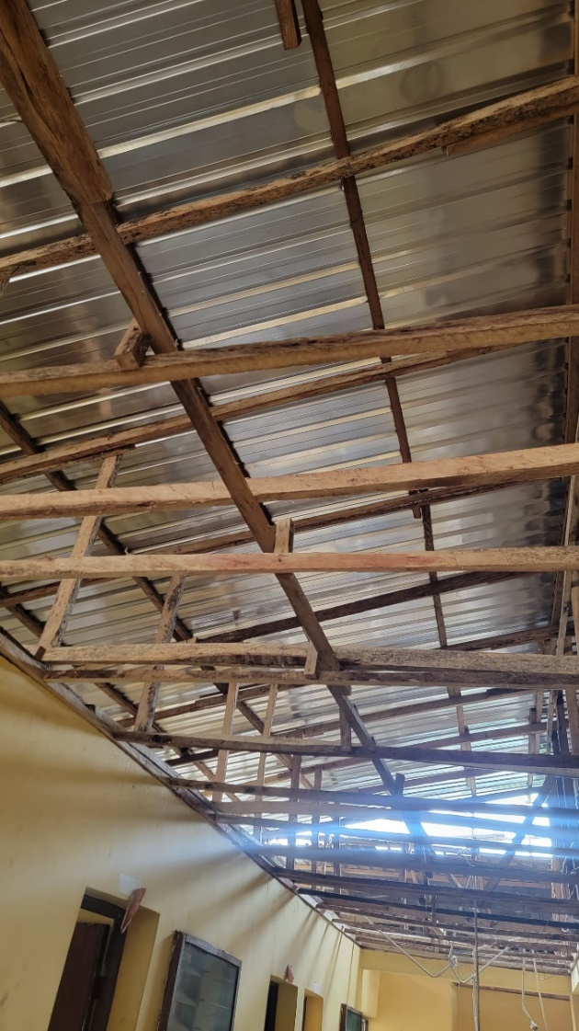
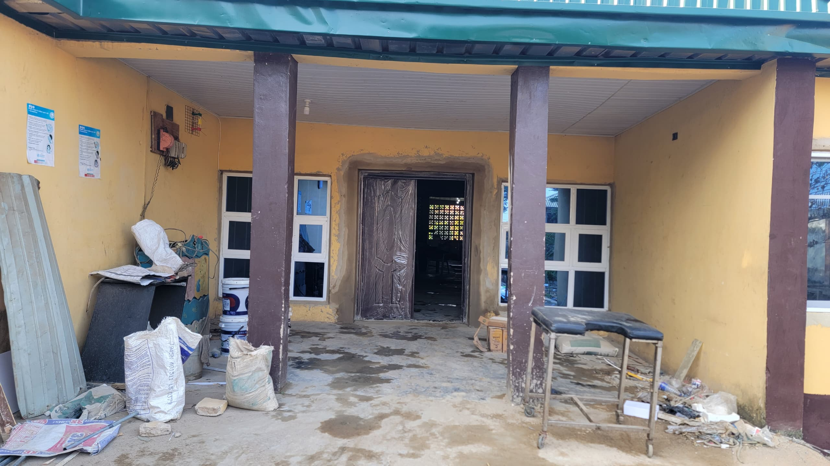
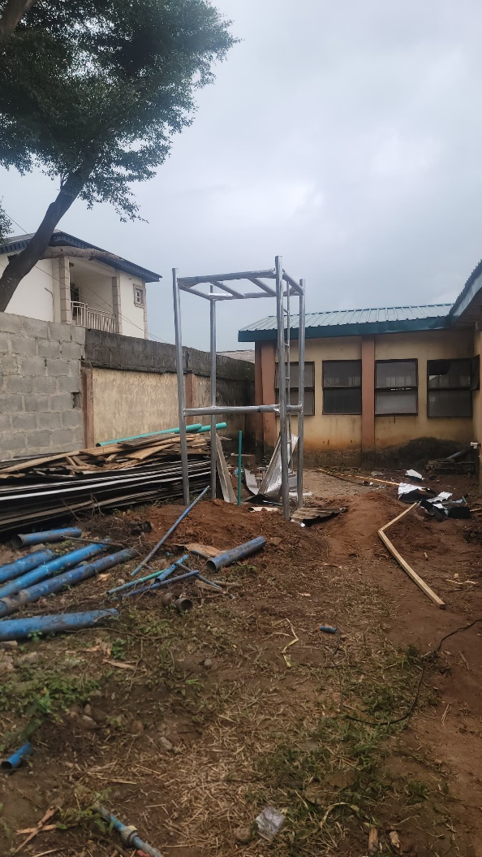
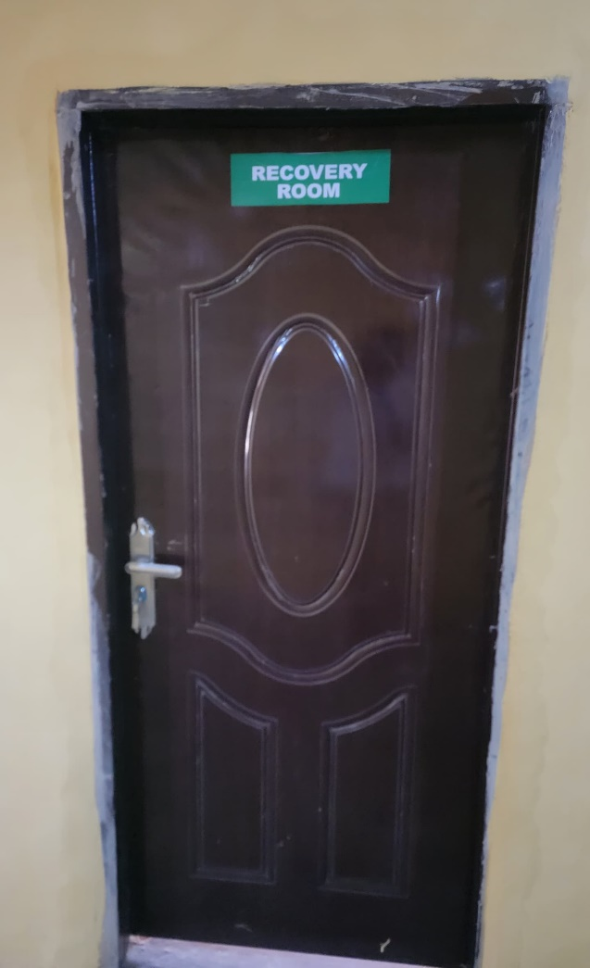

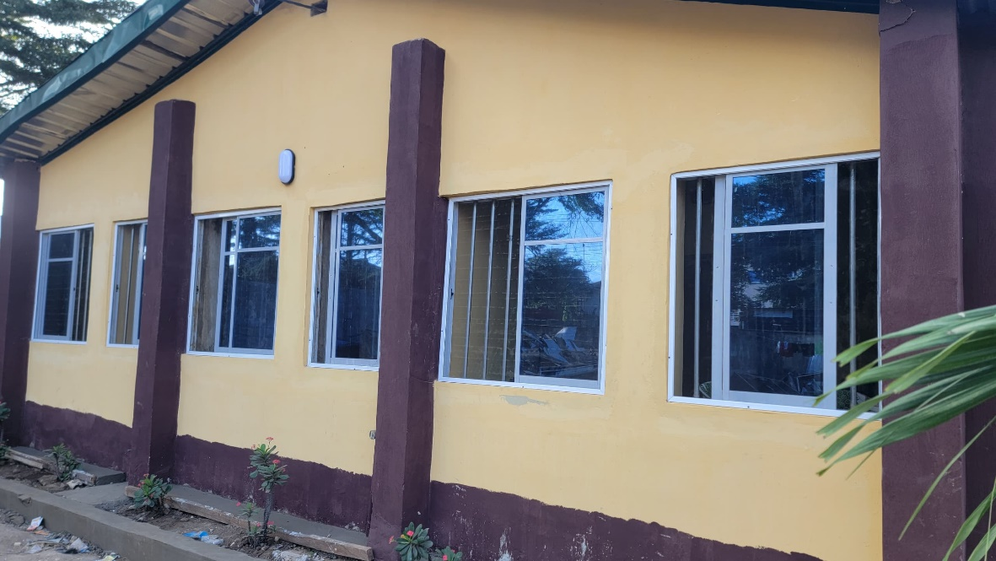
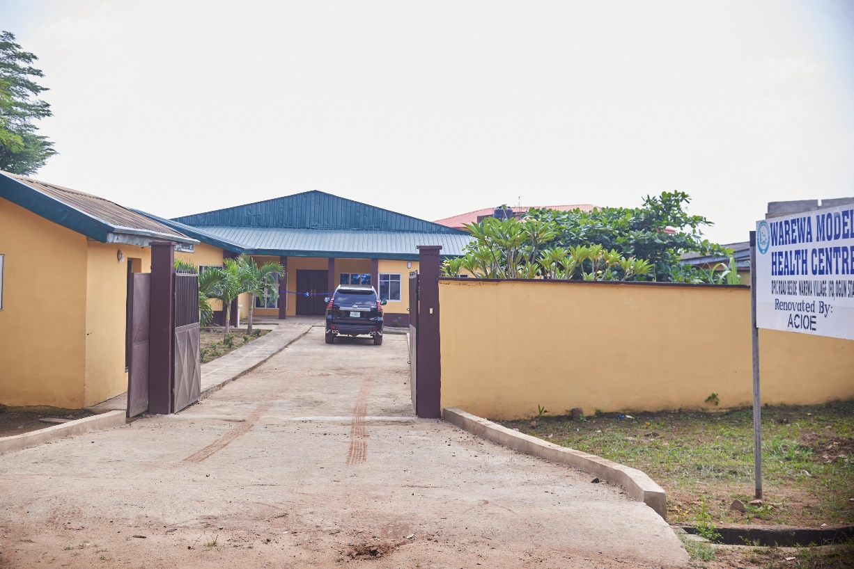
After Renovations

