School Health Talk Program

In an ever-changing global health landscape, knowledge is power and a lifeline. For Lagos state, with about 50 percent of its population being young, it is critical to provide them with correct, accurate, and easily accessible health information in a world where false information is pervasive and access to accurate health information is frequently restricted.
Adolescence is a critical human development phase characterized by rapid physical, mental, and emotional growth. During this stage, individuals develop habits and make crucial decisions that can impact their long-term health and well-being. However, in today’s digital age, where misinformation is rampant, young people often struggle to access correct, evidence-based health information. Current health education frequently falls short, leaving students to struggle with misconceptions and insufficient knowledge.
ACIOE Foundation developed the School Health Project—an initiative to equip high school students in selected schools within Ikeja Local Government Areas (LGAs) with comprehensive health education on Water, Sanitation, and Hygiene (WASH), nutrition, and life skills. The project provides students with the knowledge and resources necessary to make informed health choices, thereby promoting overall well-being and fostering a healthier generation.
The School Health Project is designed to achieve the following key objectives:
- Enhance Health Literacy: Improve young people's knowledge (high school students) in selected schools within Ikeja LGAs on health and gender-related issues, ensuring they have access to accurate, age-appropriate, and reliable information.
- Strengthen Healthcare Linkages: Establish and reinforce connections between implementation schools and nearby health facilities to enable students to access timely, comprehensive, adolescent-friendly health services without discrimination.
- Capacity Building for School Health Counselors: Equip school health counselors with the necessary training and resources to provide effective health education and counseling support to adolescents in participating schools.
Implementation and Key Activities
Following official approval from the Lagos State Ministry of Education in October 2024, ACIOE Foundation successfully launched its School Mentoring and Health Talk Program. The program is strategically designed to:
- Promote health awareness
- Encourage good hygiene practices
- Support students' overall well-being
- Empower young people with the knowledge to make informed health decisions
School Engagement and Activities
The School Health Program has visited 3 secondary schools, speaking to students during their school assembly time. During the school assembly, the team engaged students in an interactive session focused on health and well-being, personal grooming, and proper hygiene practices, emphasizing proper handwashing techniques to prevent the spread of infectious diseases
The session was designed to be engaging and educational, ensuring students actively participated in discussions. The team provided insightful information on the importance of maintaining good hygiene, including handwashing, oral care, and overall cleanliness, as well as the significance of personal grooming in promoting self-confidence and well-being.
Students demonstrated enthusiasm throughout the session, eagerly responding to questions and sharing their thoughts. The interactive nature of the engagement encouraged them to reflect on their hygiene habits and how they could implement better practices in their daily lives.
By the end of the session, the students had developed a solid understanding of essential hygiene principles and the importance of maintaining good grooming standards. This initiative not only empowered them with knowledge but also fostered a culture of personal responsibility for health and wellness within the school community.

 | School | No of the students reached
 | Agidingbi Senior Grammar School | 124 Students
 | Agidingbi Junior School | 212 Students
 | Oregun Junior High School | 165 Students

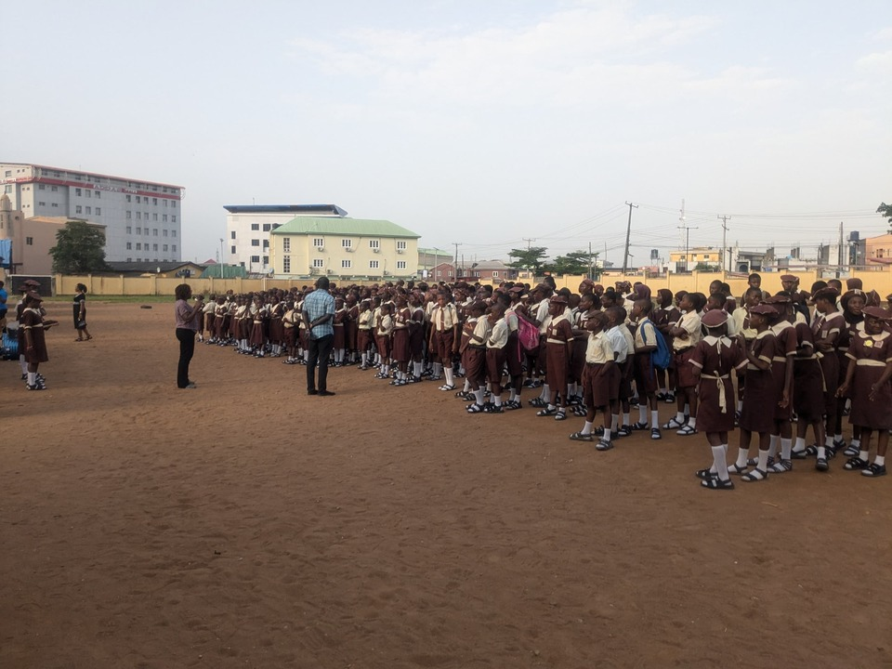
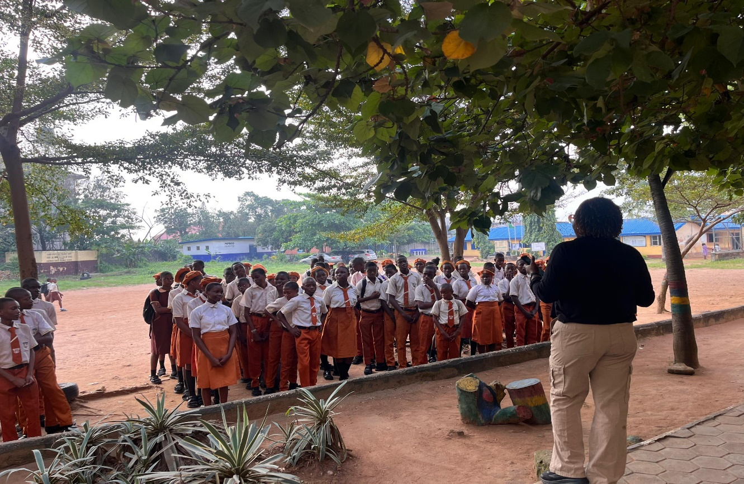
Agidingbi Junior school
Agidingbi Senior High School

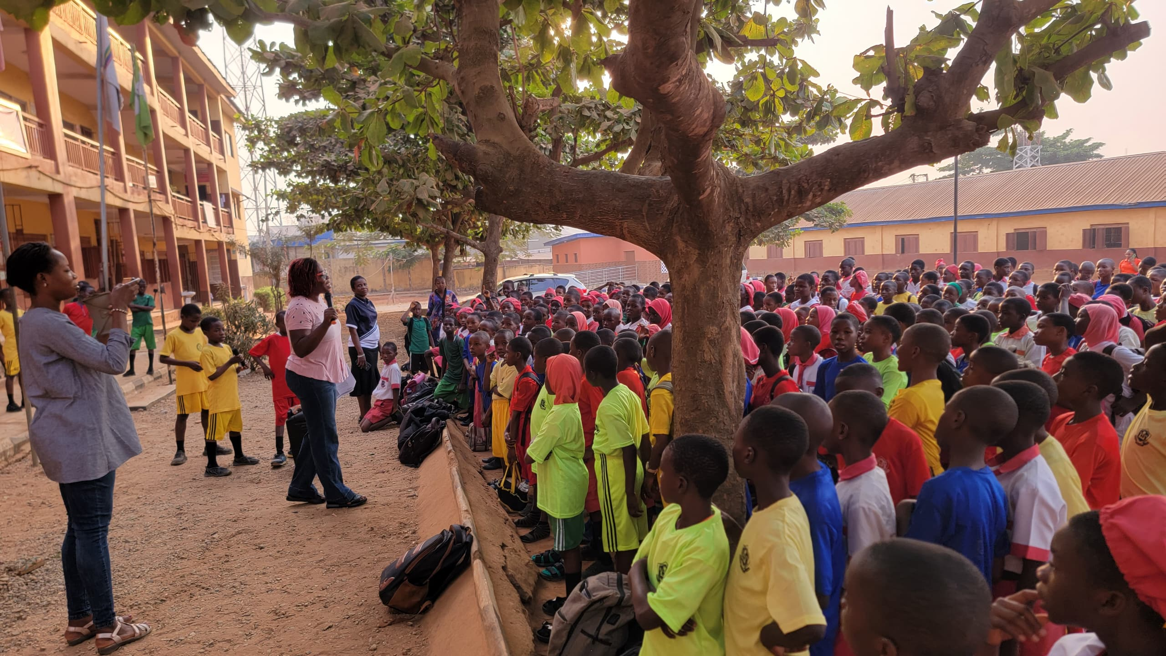
Oregun Junior High School

